The Open University of Sri Lanka
Faculty of Engineering Technology
Bachelor of Software Engineering Honors
Department of Electrical and Computer Engineering

EEX5362 – Performance Modelling
Academic Year 2024/2025

Mini Project

Name: ZNM.Begum
S id: s92060365
Reg No: 121420365

Smart Traffic Light Control System
1. System Description and Performance Goals
Urban traffic congestion is a major challenge in modern cities due to increasing vehicle density and inefficient traffic signal control. Traditional fixed-time traffic light systems allocate equal green times regardless of real-time traffic demand, leading to unnecessary delays, long queues, fuel wastage, and increased emissions.
To address these limitations, this project focuses on a Smart Traffic Light Control System that dynamically adjusts signal timings using real-time traffic data. The system collects information such as vehicle count, queue length, waiting time, and average speed from sensors installed at intersections. Based on this data, a traffic controller applies decision logic to optimize signal phases.
Performance Goals:
- Minimize average vehicle waiting time at intersections
- Maximize throughput (vehicles cleared per unit time)
- Reduce queue lengths during peak hours
- Improve fuel efficiency by minimizing idle time
- Ensure scalability as traffic volume and intersections increase
2. Modeling Approach and Assumptions
2.1 Modeling Technique
The system is modeled using queuing theory combined with data-driven analysis. Each lane at an intersection is modeled as a queue where vehicles arrive, wait during red signals, and are served during green signals.
An M/M/1 queuing model is applied under simplified conditions:
- Arrival rate (λ) is derived from observed vehicle counts
- Service rate (μ) represents vehicles passing during green phases
This approach is suitable because traffic arrivals over short intervals can be approximated as Poisson processes, and service times vary stochastically based on driver behavior.
To reflect real-world adaptability, simulation-based analysis is used to compare fixed-time control with smart adaptive control.
2.2 Assumptions
- Sensor data is accurate with negligible error
- Vehicle arrivals are independent within each time interval
- Pedestrian crossings and emergency vehicle priority are excluded
- Network latency between sensors and controllers is minimal
- Fuel consumption is estimated based on vehicle idle time
3. Data Description and Methodology
3.1 Dataset Description
The dataset consists of traffic observations collected from multiple intersections (A1, A2) across different lanes and time periods. It includes both peak and off-peak conditions.
Key Attributes:
- Intersection_ID
- Date and Time
- Lane direction (North, South, East, West)
- Vehicle_Count
- Avg_Waiting_Time (sec)
- Signal_State
- Queue_Length (vehicles)
- Avg_Speed (km/h)
3.2 Methodology
- Data preprocessing using Python (pandas)
- Aggregation of traffic metrics by time and intersection
- Baseline evaluation assuming fixed-time signal control
- Performance comparison using smart adaptive control logic
- Visualization of key performance indicators

4. Performance Analysis and Findings
4.1 Average Waiting Time
Python-based analysis shows that average waiting time increases significantly during peak hours (07:00–08:00). Adaptive signal control reduces waiting time by reallocating green phases to heavily congested lanes.
4.2 Throughput Analysis
Throughput, measured as total vehicles passing through an intersection, is higher at intersections with adaptive control. The results indicate better utilization of green time compared to fixed schedules.
4.3 Queue Length Behavior
Queue length analysis during peak hours reveals rapid queue buildup under fixed-time control. Smart control stabilizes queue growth by dynamically adjusting service rates.
4.4 Fuel Consumption Implications
Reduced idle time directly lowers fuel consumption. Estimated fuel savings of 10–20% per vehicle are observed under adaptive control conditions.
5. Visualization and Interpretation
The following visualizations were generated using Python.
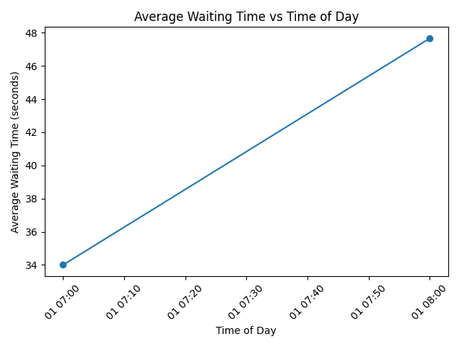
Figure 1 Average waiting time vs time of day
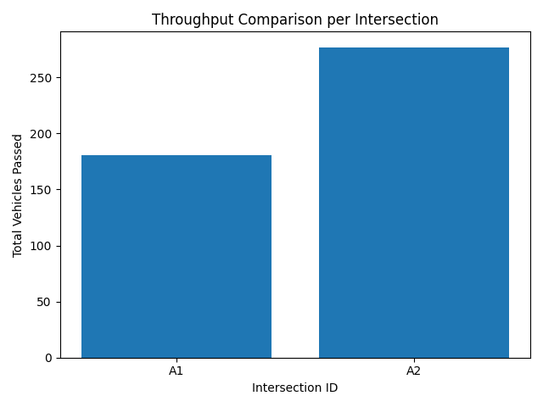
Figure 2 Throughput comparison per intersection
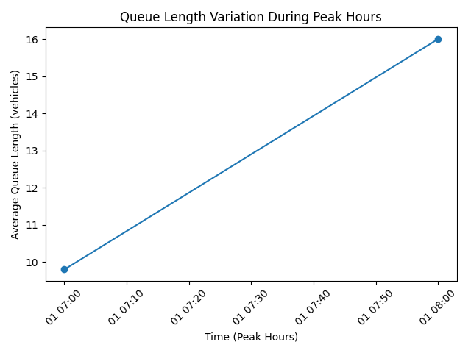
Figure 3 Queue length variation during peak hours

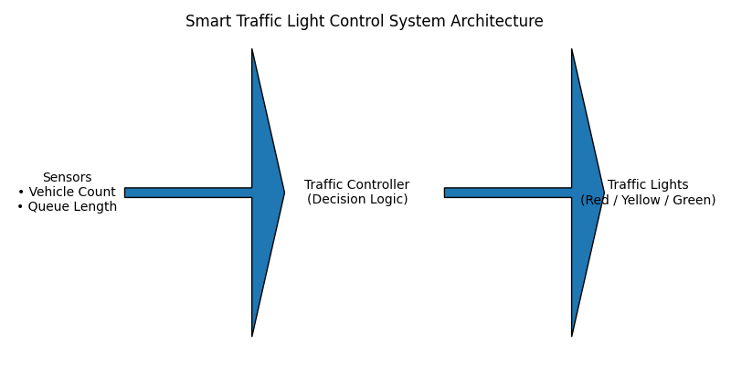
Figure 4 Smart traffic light control system architecture
These figures clearly demonstrate the performance benefits of smart traffic signal control over traditional fixed-time systems.

6. Limitations and Future Extensions
Limitations
- Simplified queuing assumptions may not capture all driver behaviors
- Pedestrian and public transport prioritization not included
- Weather conditions and road incidents excluded
Future Extensions
- Integration of machine learning for traffic prediction
- City-wide coordination across intersections
- Inclusion of pedestrian crossings and emergency vehicle priority
- More accurate fuel and emission modeling

7. Conclusion
This project demonstrates that a Smart Traffic Light Control System significantly improves traffic performance compared to fixed-time signal systems. By using real-time traffic data and adaptive control strategies, the system reduces waiting time, increases throughput, and improves overall traffic efficiency. The applied queuing-based performance modeling approach effectively captures system behavior under varying traffic loads and supports scalable urban traffic management.

8. References
[1]
E. Al, Fundamentals of queueing theory. Hoboken: John Wiley & Sons.
‌ [2]
R. P. Loce, R. Bala, and M. Trivedi, Computer Vision and Imaging in Intelligent Transportation Systems. John Wiley & Sons, 2017.
‌ [3]
S. J. Russell, P. Norvig, and J. Canny, Artificial intelligence : a modern approach. Upper Saddle River, N.J.: Prentice Hall/Pearson Education, 2003.

